Name: Laiba Asim
Sap id: 65230
Lab 9

Practice Task:
Q: program to compare two digits

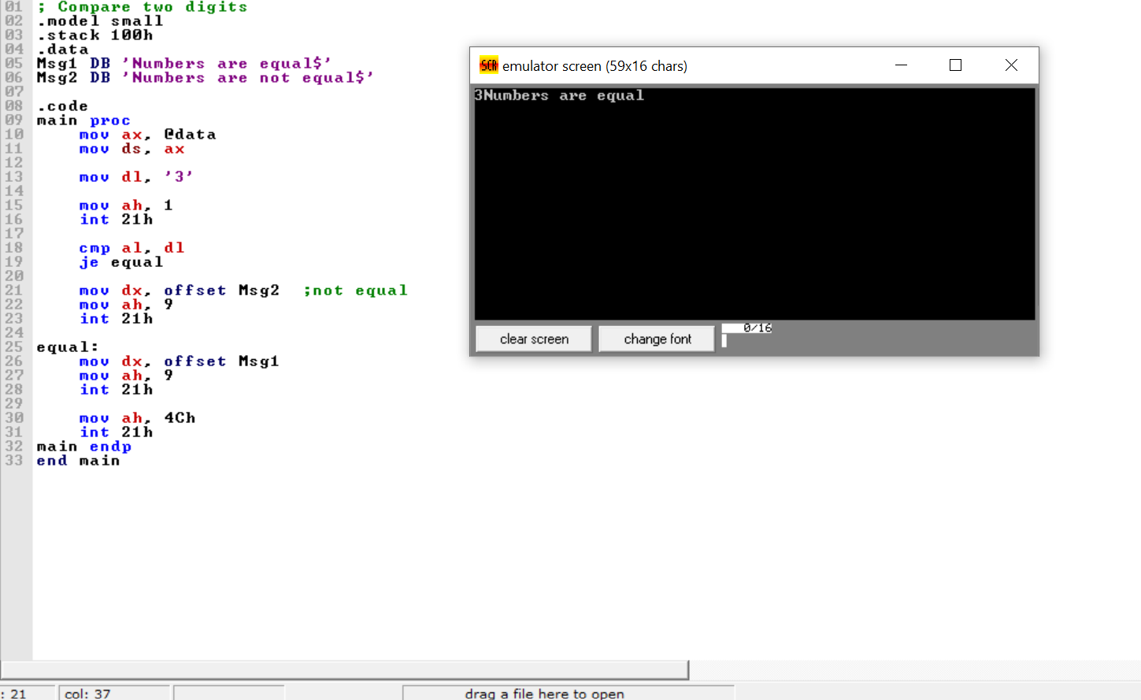

Task 1:

Q: program to calculate sum of first ten natural numbers without using counter org 100h

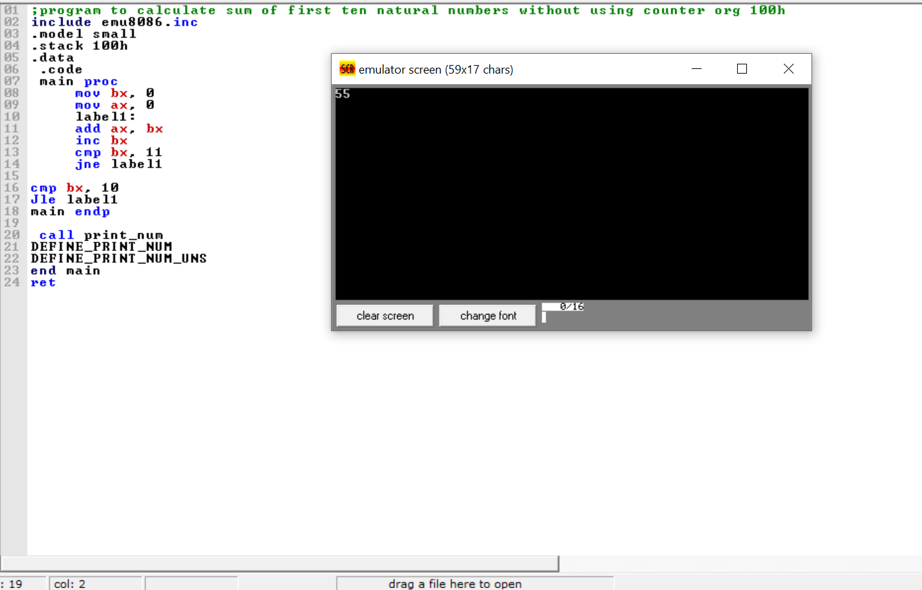

Task 2:

Q: compare two numbers by taking input from user and jump to different section of code to show if no. are equal, not equal and is greater/less
